EXERCISE 1
1. Write the complete SQL statement for creating a new database called addressbook
CREATE DATABASE ADDRESSBOOK;

2. Which statement is used to list the information about a table? How do you use this statement?
THE STATEMENT IS:
DESCRIBE table_name;
FOR EXAMPLE IN TABLE EPLOYEE_DATA,
DESCRIBE employee_data;
Answer:THIS DISPLAYS THE STRUCTURE OF THE TABLE — COLUMN NAMES, DATA TYPES, AND OTHER PROPERTIES.
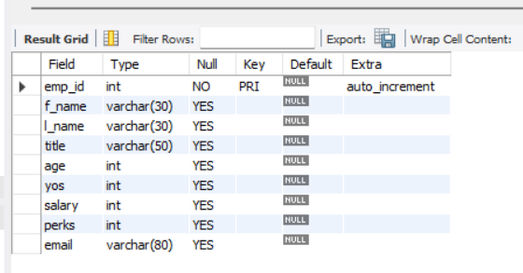

3. How would you list all the databases available on the system?
SHOW DATABASES;
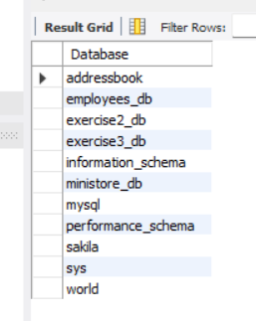

4. Write the statement for inserting the following data in employee_data table
First name: Rudolf
Last name: Reindeer
Title: Business Analyst
Age: 34
Years service: 2
Salary: 95000
Perks: 17000
Email: rudolf@bugnet.com

INSERT INTO EMPLOYEE_DATA (F_NAME, L_NAME, TITLE, AGE, YOS, SALARY, PERKS, EMAIL)
VALUES ('Rudolf', 'Reindeer', 'Business Analyst', 34, 2, 95000, 17000, 'rudolf@bugnet.com');

5. Give two forms of the SELECT statement that will list all the data in employee_data table.
SELECT * FROM EMPLOYEE_DATA;
SELECT F_NAME, L_NAME, TITLE, AGE, YOS, SALARY, PERKS, EMAIL FROM EMPLOYEE_DATA;

6. What will select f_name, email FROM employee_data; display?
Answer: IT WILL DISPLAY ONLY THE FIRST NAME AND EMAIL ADDRESSE OF THE EMPLOYEE FROM THE TABLE.
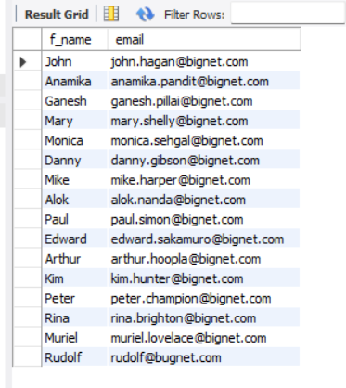

7. Write the statement for listing data from salary, perks, and yos columns of employee_data table.
SELECT salary, perks, yos FROM employee_data;
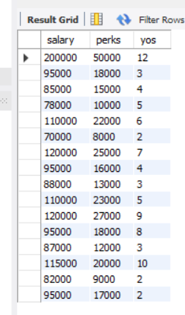

8. How can you find the number of rows in a table using the SELECT statement?
SELECT COUNT(*) FROM employee_data;
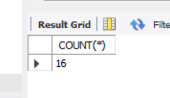
9. What will select salary, l_name FROM employee_data; display?
Answer: IT WILL DISPLAY THE SALARY AND LAST NAME OF EMPLOYEE FROM THE TABLE.
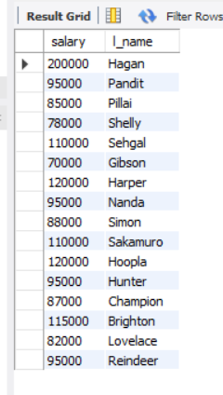

EXERCISE 2
1. Write the SELECT statement to extract the IDs of employees who are more than 30 years of age.
SELECT EMP_ID
FROM EMPLOYEE_DATA
WHERE AGE > 30;
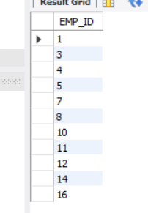

2. Write the SELECT statement to extract the first and last names of all web designers.
SELECT F_NAME, L_NAME
FROM EMPLOYEE_DATA
WHERE JOB_TITLE = 'Web Designer';

3. What will the following SELECT statement display: SELECT * FROM employee_data WHERE salary <= 100000?
Answer: THIS WILL DISPLAY ALL COLUMNS (ALL FIELDS) FOR EMPLOYEES WHOSE SALARY IS LESS THAN OR EQUAL TO 100,000.
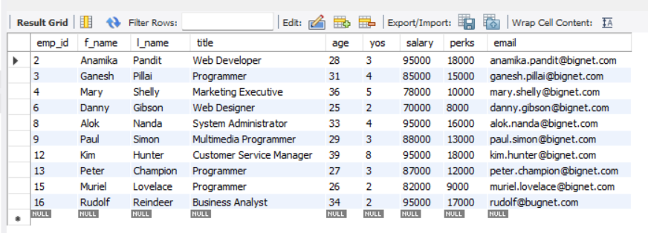

4. How will you display the salaries and perks for employees who have more than $16,000 as perks?
SELECT SALARY, PERKS
FROM EMPLOYEE_DATA
WHERE PERKS > 16000;
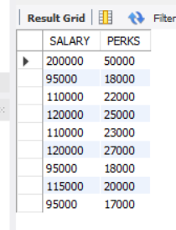

5. List all employee names (last name followed by first name) who hold the title of Marketing Executive.
SELECT CONCAT(LAST_NAME, ', ', FIRST_NAME) AS FULL_NAME
FROM EMPLOYEE_DATA
WHERE JOB_TITLE = 'Marketing Executive';

EXERCISE 3
1. List all employees whose last names begin with ‘P’.
SELECT F_NAME, L_NAME
FROM EMPLOYEE_DATA
WHERE L_NAME LIKE 'P%';
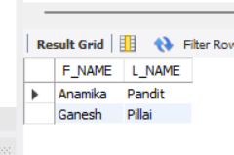
2. Display the names of all employees in the marketing division.
SELECT F_NAME, L_NAME
FROM EMPLOYEE_DATA
WHERE DIVISION = 'Marketing';

3. What will the following statement display SELECT f_name, l_name, salary FROM employee_data WHERE f_name LIKE '%k%';
Answer: IT WILL DISPLAY THE FIRST NAME, LAST NAME, AND SALARY OF ALL EMPLOYEES WHOSE FIRST NAME CONTAINS THE LETTER “K”
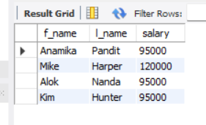

4.List the last names and titles of all programmers.
SELECT L_NAME, TITLE
FROM EMPLOYEE_DATA
WHERE TITLE LIKE '%PROGRAMMER%';

EXERCISE 4

1. List the first and last names of employees who draw less than or equal to 90,000 and are not Programmers, Senior Programmers, or Multimedia Programmers.

SELECT f_name, l_name
FROM employee_data
WHERE salary <= 90000
AND title NOT IN ('Programmer', 'Senior Programmer', 'Multimedia Programmer');
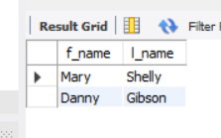

2. What does this statement display?

SELECT l_name, f_name
FROM employee_data
WHERE title NOT LIKE '%marketing%'
AND age < 30;
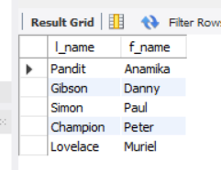

3. List all IDs and names of employees between 32 and 40 years of age.SQL

SELECT emp_id, f_name, l_name
FROM employee_data
WHERE age BETWEEN 32 AND 40;
-- This displays employee IDs and names whose ages fall within 32 to 40.
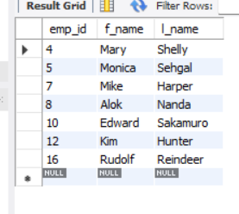

4. Select names of all employees who are 32 years of age and are not programmers.

SELECT f_name, l_name
FROM employee_data
WHERE age = 32
AND title NOT LIKE '%Programmer%';

EXERCISE 5
1. List all employees who hold the titles of “Senior Programmer” and “Multimedia Programmer”.
SELECT F_NAME, L_NAME, TITLE
FROM EMPLOYEE_DATA
WHERE TITLE IN ('Senior Programmer', 'Multimedia Programmer');

2. List all employee names with salaries for employees who draw between ₱70,000 and ₱90,000.
SELECT F_NAME, L_NAME, SALARY
FROM EMPLOYEE_DATA
WHERE SALARY BETWEEN 70000 AND 90000;

3. What will the following statement display?
SELECT F_NAME, L_NAME, TITLE
FROM EMPLOYEE_DATA
WHERE TITLE NOT IN ('Programmer', 'Senior Programmer', 'Multimedia Programmer');
Answer: IT WILL DISPLAY ALL EMPLOYEES WHOSE TITLES ARE NOT RELATED TO PROGRAMMING.
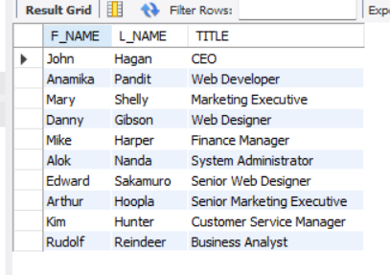
4. Here is a more complex statement that combines both BETWEEN and IN.What will it display?
SELECT F_NAME, L_NAME, TITLE, AGE
FROM EMPLOYEE_DATA
WHERE TITLE NOT IN ('Programmer', 'Senior Programmer', 'Multimedia Programmer')
AND age NOT BETWEEN 28 AND 32;
Answer: THIS DISPLAYS EMPLOYEES WHO ARENOT PROGRAMMERS OF ANY TYPE, AND NOT BETWEEN 28 AND 32 YEARS OLD, IT WILL BE UNDER 28 OR OVER 32.
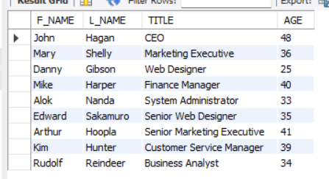

EXERCISE 6

1. Order all employees on the basis of the salary they draw.
SELECT EMP_ID, F_NAME, L_NAME, TITLE, SALARY
FROM EMPLOYEE_DATA
ORDER BY SALARY;

2. List all employees in descending order of their years of service.
SELECT EMP_ID, F_NAME, L_NAME, YEARS_OF_SERVICE
FROM EMPLOYEE_DATA
ORDER BY YEARS_OF_SERVICE DESC;

3. What does the following statement display?
SELECT emp_id, l_name, title, age
FROM employee_data
ORDER BY title DESC, age ASC;
Answer: THIS DISPLAYS ALL EMPLOYEES SORTED PRIMARILY BY JOB TITLE IN DESCENDING ORDER, AND WITHIN EACH TITLE, SORTED BY AGE IN ASCENDING ORDER.
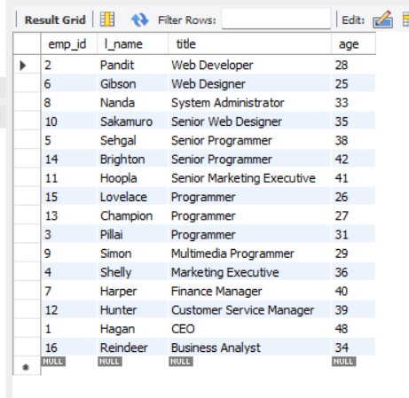
4. Display employees (last names followed by first names) who hold the title of either “Programmer” or “Web Designer” and sort their last names alphabetically.
SELECT CONCAT(L_NAME, ', ', F_NAME) AS FULL_NAME, TITLE
FROM EMPLOYEE_DATA
WHERE TITLE IN ('PROGRAMMER', 'WEB DESIGNER')
ORDER BY L_NAME ASC;

EXERCISE 7

1. List the names of the 5 youngest employees in the company.
SELECT F_NAME, L_NAME, AGE
FROM EMPLOYEE_DATA
ORDER BY AGE ASC
LIMIT 5;

2. Extract the next 5 entries starting with the 10 row.
SELECT *
FROM EMPLOYEE_DATA
LIMIT 9, 5;

3. Display the names and salary of the employee who draws the largest salary.
SELECT F_NAME, L_NAME, SALARY
FROM EMPLOYEE_DATA
ORDER BY SALARY DESC
LIMIT 1;

4. What does the following statement display?
SELECT emp_id, age, perks
FROM employee_data
ORDER BY perks DESC
LIMIT 10;
Answer: IT DISPLAYS THE 10 EMPLOYEES WITH THE HIGHEST PERKS, SORTED FROM LARGEST TO SMALLEST PERKS.
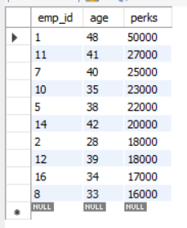

EXERCISE 8

1. How many unique salary packages does our company “Bignet” offer? List them in descending order.
SELECT DISTINCT SALARY
FROM EMPLOYEE_DATA
ORDER BY SALARY DESC;
SELECT COUNT(DISTINCT SALARY) AS UNIQUE_SALARY_PACKAGES FROM EMPLOYEE_DATA;
Answer: unique_salary_packages:11
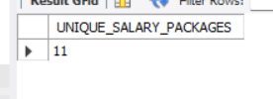

2. How many distinct first names do we have in our database?
SELECT COUNT(DISTINCT F_NAME) AS DISTINCT_FIRST_NAMES
FROM EMPLOYEE_DATA;
SELECT DISTINCT F_NAME
FROM EMPLOYEE_DATA
ORDER BY F_NAME ASC;
Answer: unique_salary_packages:11

2. How many distinct first names do we have in our database?
SELECT COUNT(DISTINCT F_NAME) AS DISTINCT_FIRST_NAMES
FROM EMPLOYEE_DATA;
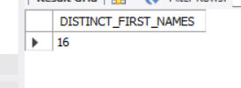
SELECT DISTINCT F_NAME
FROM EMPLOYEE_DATA
ORDER BY F_NAME ASC;

EXERCISE 9
1. List the minimum perks package.

SELECT MIN(perks) AS minimum_perks
FROM employee_data;
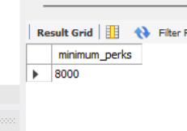

2. List the maximum salary given to a Programmer.

SELECT MAX(salary) AS max_programmer_salary
FROM employee_data
WHERE title = 'Programmer';
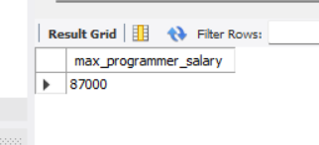

3. Display the age of the oldest Marketing Executive.

SELECT MAX(age) AS oldest_marketing_exec_age
FROM employee_data
WHERE title = 'Marketing Executive';
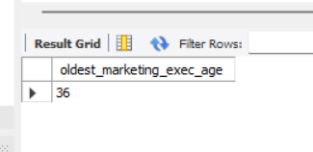

4. (Tricky) Find the first and last names of the oldest employee.

SELECT f_name, l_name
FROM employee_data
WHERE age = (SELECT MAX(age) FROM employee_data);

EXERCISE 10

1. Display the sum of ages of all employees.

SELECT SUM(age) AS total_age
FROM employee_data;
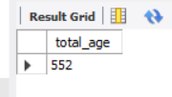

2. Calculate the total years of service of all employees.

SELECT SUM(yos) AS total_years_of_service
FROM employee_data;
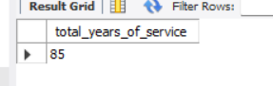

3. Calculate the sum of salaries and average age of employees who are Programmers.

SELECT SUM(salary) AS total_salary, AVG(age) AS average_age
FROM employee_data
WHERE title = 'Programmer';
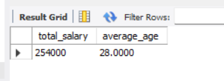

4. What do you understand from this statement?

SELECT (SUM(perks) / SUM(salary) * 100)
FROM employee_data;
Answer: calculates the percentage ratio of total perks to total salaries for all employees — essentially, what percent of total salary expenditure is given as perks.

EXERCISE 11

1. Count the number of employees who have been with BigNet for four or more years.

SELECT COUNT(*) AS 'Employees with 4 or more years'
FROM employee_data
WHERE yos >= 4;
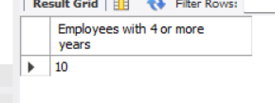

2. Count employees based on their ages.

SELECT age, COUNT(*) AS 'Number of Employees'
FROM employee_data
GROUP BY age;
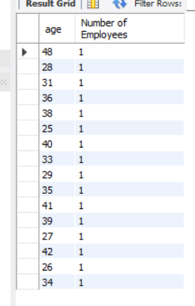

3. Modify the above so that the ages are listed in descending order.

SELECT age, COUNT(*) AS 'Number of Employees'
FROM employee_data
GROUP BY age
ORDER BY age DESC;

4. Find the average age of employees in different departments (titles).

SELECT title, AVG(age) AS 'Average Age'
FROM employee_data
GROUP BY title;

5. Change the above so that the data is displayed in descending order of average ages.

SELECT title, AVG(age) AS 'Average Age'
FROM employee_data
GROUP BY title
ORDER BY AVG(age) DESC;

6. Find and list the percentage of perks (perks/salary * 100) for each employee, sorted in descending order.

SELECT f_name, l_name, (perks / salary * 100) AS 'Perk Percentage'
FROM employee_data
ORDER BY 'Perk Percentage' DESC;

EXERCISE 12

1. List departments and average ages where the average age is more than 30.

SELECT title, AVG(age) AS 'Average Age'
FROM employee_data
GROUP BY title
HAVING AVG(age) > 30;

EXERCISE 13

1. Which command displays the MySQL version?
SELECT VERSION();

2. Use the SELECT command to evaluate 4 × 4 × 4 and name the column Cube of 4.
SELECT (4 * 4 * 4) AS 'Cube of 4';

3. Display your name using SELECT.
SELECT 'Jamaima Rabulan' AS 'Name';
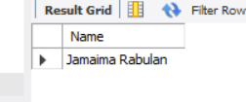

EXERCISE 14

1. Our CEO falls in love with the petite Web Developer, Anamika Pandit.He now wants her last name to be changed to Sharma.

UPDATE employee_data
SET l_name = 'Sharma'
WHERE f_name = 'Anamika' AND title = 'Web Developer';

2. All Multimedia Programmers now want to be called Multimedia Specialists.

UPDATE employee_data
SET title = 'Multimedia Specialist'
WHERE title = 'Multimedia Programmer';

3. After his marriage, the CEO gives everyone a raise. Increase the salaries of all employees (except the CEO) by $10,000.

UPDATE employee_data
SET salary = salary + 10000
WHERE title <> 'CEO';

EXERCISE 15

1. List all employee IDs and birth dates of employees who were born before 1965.
SELECT e_id, birth_date
FROM employee_per
WHERE birth_date < '1965-01-01';

2. Display IDs and birth dates of employees born between 1970 and 1972.

SELECT e_id, birth_date
FROM employee_per
WHERE birth_date BETWEEN '1970-01-01' AND '1972-12-31';

EXERCISE 16

- List IDs, birth dates, and emails of employees born in April.

SELECT e_id, birth_date, p_email
FROM employee_per
WHERE MONTHNAME(birth_date) = 'April';

- Display IDs, birth dates, and spouse names of employees born in 1969,and sort by spouse name.

SELECT e_id, birth_date, s_name
FROM employee_per
WHERE YEAR(birth_date) = 1969
ORDER BY s_name;

- List employee IDs for employees born under the current month.

SELECT e_id
FROM employee_per
WHERE MONTH(birth_date) = MONTH(CURRENT_DATE);

- How many unique birth years do we have?

SELECT COUNT(DISTINCT YEAR(birth_date)) AS 'Unique Birth Years'
FROM employee_per;
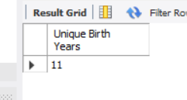

- Display a list of unique birth years and the number of employees born each year.

SELECT YEAR(birth_date) AS 'Birth Year', COUNT(*) AS 'Number of Employees'
FROM employee_per
GROUP BY YEAR(birth_date);
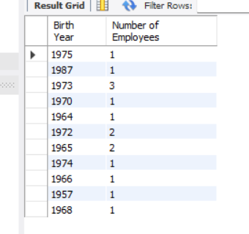

6. How many employees were born under each month?Display month names (not numbers), and sort so that the month with the most births is shown first.

SELECT MONTHNAME(birth_date) AS 'Month', COUNT(*) AS 'Number of Employees'
FROM employee_per
GROUP BY MONTHNAME(birth_date)
ORDER BY COUNT(*) DESC;
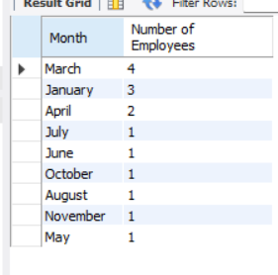

EXERCISE 17

1. Find and list the IDs and spouse names of all employees who are married.

SELECT e_id, s_name
FROM employee_per
WHERE m_status = 'Y';

2. Change the above so that the display is sorted by spouse names.

SELECT e_id, s_name
FROM employee_per
WHERE m_status = 'Y'
ORDER BY s_name;

3. How many employees do we have under each sex (male and female)?

SELECT sex, COUNT(*) AS 'Number of Employees'
FROM employee_per
GROUP BY sex;
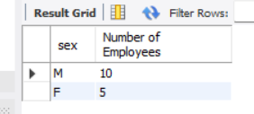

4. How many of our employees are married and unmarried?

SELECT m_status, COUNT(*) AS 'Number of Employees'
FROM employee_per
GROUP BY m_status;
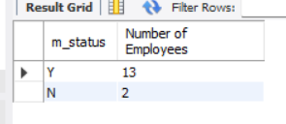

Find the total number of children.

SELECT SUM(children) AS 'Total Number of Children'
FROM employee_per
WHERE children IS NOT NULL;
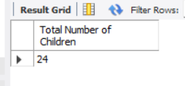
6. Make unique groups of children and find the number in each group.Sort the display so that the group with maximum children is at the top.

SELECT children, COUNT(*) AS 'Number of Employees'
FROM employee_per
WHERE children IS NOT NULL
GROUP BY children
ORDER BY children DESC;

create and select database
CREATE DATABASE addressbook;
USE addressbook;

CREATE TABLE IF NOT EXISTS employee_data (
emp_id INT AUTO_INCREMENT PRIMARY KEY,
f_name VARCHAR(30),
l_name VARCHAR(30),
title VARCHAR(50),
age INT,
yos INT,
salary INT,
perks INT,
email VARCHAR(80)
) ENGINE=InnoDB;

INSERT INTO employee_data (f_name, l_name, title, age, yos, salary, perks, email) VALUES
('John', 'Hagan', 'CEO', 48, 12, 200000, 50000, 'john.hagan@bignet.com'),
('Anamika', 'Pandit', 'Web Developer', 28, 3, 95000, 18000, 'anamika.pandit@bignet.com'),
('Ganesh', 'Pillai', 'Programmer', 31, 4, 85000, 15000, 'ganesh.pillai@bignet.com'),
('Mary', 'Shelly', 'Marketing Executive', 36, 5, 78000, 10000, 'mary.shelly@bignet.com'),
('Monica', 'Sehgal', 'Senior Programmer', 38, 6, 110000, 22000, 'monica.sehgal@bignet.com'),
('Danny', 'Gibson', 'Web Designer', 25, 2, 70000, 8000, 'danny.gibson@bignet.com'),
('Mike', 'Harper', 'Finance Manager', 40, 7, 120000, 25000, 'mike.harper@bignet.com'),
('Alok', 'Nanda', 'System Administrator', 33, 4, 95000, 16000, 'alok.nanda@bignet.com'),
('Paul', 'Simon', 'Multimedia Programmer', 29, 3, 88000, 13000, 'paul.simon@bignet.com'),
('Edward', 'Sakamuro', 'Senior Web Designer', 35, 5, 110000, 23000, 'edward.sakamuro@bignet.com'),
('Arthur', 'Hoopla', 'Senior Marketing Executive', 41, 9, 120000, 27000, 'arthur.hoopla@bignet.com'),
('Kim', 'Hunter', 'Customer Service Manager', 39, 8, 95000, 18000, 'kim.hunter@bignet.com'),
('Peter', 'Champion', 'Programmer', 27, 3, 87000, 12000, 'peter.champion@bignet.com'),
('Rina', 'Brighton', 'Senior Programmer', 42, 10, 115000, 20000, 'rina.brighton@bignet.com'),
('Muriel', 'Lovelace', 'Programmer', 26, 2, 82000, 9000, 'muriel.lovelace@bignet.com');

CREATE TABLE IF NOT EXISTS employee_per (
e_id INT PRIMARY KEY, -- should match employee_data.emp_id
address VARCHAR(100),
phone VARCHAR(20),
p_email VARCHAR(80),
birth_date DATE,
sex ENUM('M','F'),
m_status ENUM('Y','N'),
s_name VARCHAR(80),
children INT
) ENGINE=InnoDB;

INSERT INTO employee_per (e_id, address, phone, p_email, birth_date, sex, m_status, s_name, children) VALUES
(1, 'Manila', '09170001111', 'john.hagan@gmail.com', '1975-01-12', 'M', 'Y', 'Jane Donner', 2),
(2, 'Quezon City', '09180002222', 'anamika.pandit@gmail.com', '1987-03-09', 'F', 'Y', 'Manish Sharma', 0),
(3, 'Makati', '09190003333', 'ganesh.pillai@gmail.com', '1973-01-20', 'M', 'Y', 'Sandhya Pillai', 3),
(4, 'Pasig', '09170004444', 'mary.shelly@gmail.com', '1970-07-18', 'F', 'N', NULL, NULL),
(5, 'Taguig', '09180005555', 'monica.sehgal@gmail.com', '1964-03-06', 'F', 'Y', 'Edgar Alan', 1),
(6, 'Cavite', '09190006666', 'danny.gibson@gmail.com', '1972-03-16', 'M', 'Y', 'Betty Cudly', 1),
(7, 'Mandaluyong', '09170007777', 'mike.harper@gmail.com', '1965-06-28', 'M', 'Y', 'Stella Stevens', 4),
(8, 'Bulacan', '09180008888', 'alok.nanda@gmail.com', '1973-10-09', 'M', 'Y', 'Manika Nanda', 2),
(9, 'Rizal', '09190009999', 'paul.simon@gmail.com', '1974-04-18', 'M', 'Y', 'Muriel Lovelace', 2),
(10, 'Laguna', '09171110000', 'edward.sakamuro@gmail.com', '1966-08-20', 'M', 'Y', 'Rina Brighton', 3),
(11, 'Pampanga', '09182221111', 'arthur.hoopla@gmail.com', '1957-11-04', 'M', 'Y', 'Rina Brighton', 1),
(12, 'Cebu', '09193332222', 'kim.hunter@gmail.com', '1968-05-19', 'M', 'Y', 'Matt Shikari', 2),
(13, 'Baguio', '09174443333', 'peter.champion@gmail.com', '1973-01-20', 'M', 'Y', 'Ruby Richer', 1),
(14, 'Davao', '09185554444', 'muriel.lovelace@gmail.com', '1972-03-16', 'F', 'N', NULL, NULL),
(15, 'Iloilo', '09196665555', 'rina.brighton@gmail.com', '1965-04-28', 'F', 'Y', 'Matt Shikari', 2);

